Project Initiation Document
Change references and status to Final when signed
Document Reference: LL/EJL/001
Status: DRAFT v1, 01 June 2015

Project Initiation Document
for the
Objective
Statement

Recruitment and Selection
of a key Account Manager by 1 September 2015

Approved:
Name | Rôle | Signature | Date
Eddie Lunn | Project Owner | Eddie Lunn | 01 June 15
Alan Sarsby | Head of Personnel | Alan Sarsby | 02 June 15
Alison Grimes | Finance Director | Ali Grimes | 02 June 15
Peter Smith | Project Leader | Pete Smith | 01 Jun 15

Change the footer references to suit your organisation
Project Governance:
Signatures and dates for commitment and authority

Introduction
The restructuring of the Marketing and Sales territories has created the need for an additional key Account Manager to lead and manage the development and growth of nominated key accounts to protect £2m revenues and grow sales by 20% p.a.
Include values or benefits
Project outcome
The purpose of this recruitment and selection project is …
To appoint a key Account manager by 1st September 2015
Objective stated as an outcome
values or benefits

To achieve this outcome this project is to market the vacancy, design suitable assessment method, assess and evaluate the candidates, select and appoint the best candidate, review the project and make recommendations to the Project Board for future recruitment.
The approach is to liaise with the line manager and the internal personnel consultant to conduct a role analysis, generate a job specification and the person specification. These are to be used to inform the marketing of the vacancy, the assessment design and the candidate evaluation.

Project Board
The Project Board for this recruitment project includes:
Key Stakeholders form the
Project Board
- Eddie Lunn, Sales and Marketing — Project Owner
- Alan Sarsby, Head of Personnel
- Alison Grimes, Finance Director
- Peter Smith, Project Leader
The Project Board will meet at the beginning to launch the project, at the end to review the learning points and prior to the candidate assessment.
The Project Leader will provide weekly updates of progress, every Monday morning, by e-mail to the Project Board and those directly involved in the project.

Business Drivers
The Operational Board approved the business case for this new post at their meeting on 1 May 2015.
The main benefits are expected to be more frequent customer contact leading to competitive advantage, customer retention plus new sales order value.
The business value is estimated as: Retention of current revenue estimated at £2m per annum. Lost opportunity cost is at £200k per quarter and potential growth over 5 years of £2.5m
The investment, as total cost of employment, for the post is £124k per annum

Outline plan

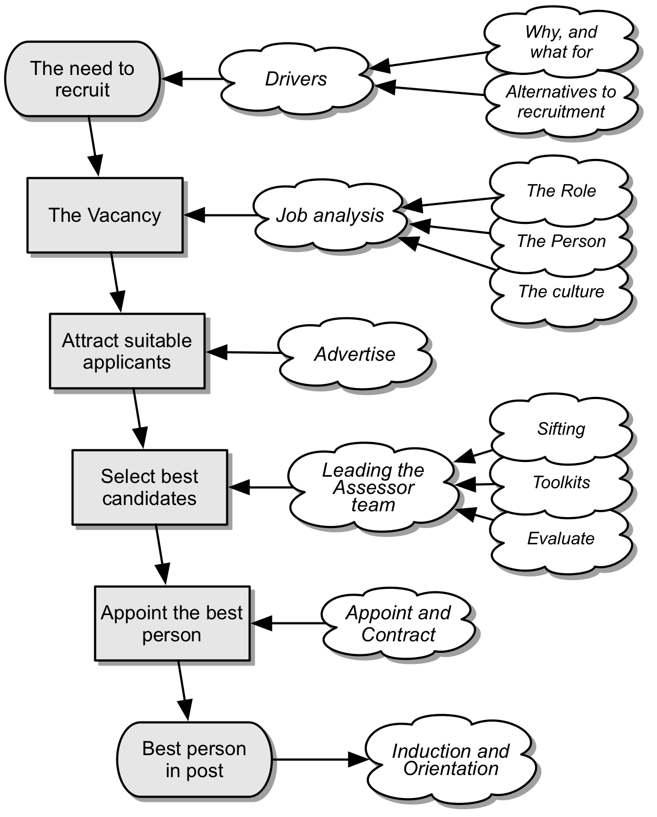

Project deliverables
The project is expected to produce the following outputs and outcomes:
Ultimate deliverable | Responsible person
Best candidate selected, appointment confirmed and candidate in post | Project Leader — Peter Smith
Assessed performance — for use of the Line Manager in induction and training post appointment | Lead Assessor — Paul Bisset  Individual responsibilities  Project Leader remains accountable
Project review | Project Leader — Peter Smith

Enabling deliverables | Responsible person
Budget approved | FD — Alison Grimes
Resources approved | Project Owner — Eddie Lunn
Role analysis — Job specification for use with the job description, assessment design and candidate evaluation  Key outputs with Brief explanation to aid understanding | Line Manager — Anne Downton
Role analysis — Person specification for use with the job description, assessment design and candidate evaluation | Line Manager — Anne Downton
Marketing plan — strategy: when and where to advertise to attract suitable applicants | Marketing Agent — Ian Somme
Advert placed — internal market, local, national or specialist press | Marketing Agent — Ian Somme
Application — short-listing | Line Manager — Anne Downton
Design assessment activities, recording of performance and an evaluation grid | Lead Assessor — Paul Bisset
Candidate assessment plan — what, where and when with selected, trained assessors | Lead Assessor — Paul Bisset
Implement candidate assessment, and evaluation programme | Lead Assessor — Paul Bisset
Final selection and appointment | Line Manager — Anne Downton
Contract issued, signed and returned | Personnel — Steve Balon
Project Review | Project Leader — Peter Smith
Project Board report | Project Leader — Peter Smith

Resource requirements
The Project Leader is allocated to the project for 16 hours a week over 16 weeks to lead the project, and co-ordinate resources.
The Line Manager is required to allocate 32 hours for the following activities:
Role analysis to produce a job specification and the person specification | 6 hours
Paper-sift and short-listing candidates | 8 hours
Agree and test the design of the Candidate assessment plan | 10 hours
Confirm best candidate, agree contract details with personnel | 4 hours
A Final review with recommendations to the Project Board. | 4 hours

The Personnel Consultant is required to allocate 44 hours for the following activities:
Role analysis to produce a job specification and person specification. | 12 hours
Contributing to, and agreeing advertising plan including media placement. | 10 hours
Confirm with Line Manager the final short-list of suitable candidates. | 2 hours
Agree and test the design of the Candidate assessment plan. | 10 hours
Review the evaluation grid to confirm fair evaluation practice. | 2 hours
Preparation of contracts, terms of employment. | 4 hours
Due diligence checks | 4 hours
A Final review with recommendations to the Project Board. | 4 hours

Other resources required include:
Skilled designer to craft the advert.  (Expected cost based on previous contracts.) | £2k
Placement of the advert in relevant media  (Half-page, colour, x 2 inserts) | £4k
Skilled designer for the candidate assessment plan. | £4k
Materials, logistics, rooms, refreshments, for assessment day.  (£100 per candidate x 6) | £600
Other costs — materials | £1400

The budget required for the recruitment project is £12k,
(excluding people and opportunity cost).

Risks
The role analysis — High quality, well-formed, job specification and the person specification — are crucial inputs to the advert, the new job description, the paper-sift, the candidate assessment plan, the evaluation and the ultimate appointment of the best candidate. To minimise this risk requires the timely availability of the line manager and personnel consultant
Marketing the vacancy — The availability of a skilled marketer and the Head of Personnel to approve are critical to the timely placement of the advert in relevant media. Budget has been approved.
High volumes of suitable candidates — Our brand is recognised in the market and the remuneration package on offer is competitive, hence a large number of applicants is expected. Contingency may be required for application processing and the paper-sift. Delays to the project timetable mean we lose good candidates.
An effective candidate assessment programme — The design of the assessment and evaluation is the critical element in selection process. To minimise any risk, the plan includes a dry-run test and rehearsal using internal volunteers, selected observers, and trained assessors at least one week before the assessment day.
Death valley risk — The time between the interview and a job offer is the most critical delay. Good candidates are likely to be in receipt of competing job offers. This delay gives good candidates the opportunity to go elsewhere.

Key milestones

Phase 1: Preparation
Stage | Project activity | Week Commencing
Week 01 | Preparation, PID, and project setup.  Role analysis starts | 01 June 15
Week 02 | Job specification completed  Person specification completed | 08 June 15
Week 03 | Advert ready for proof-reading  Assessment design starts | 15 June 15
Week 04 - 05 | Advert placed in media | 22 – 29 June 15

Phase 2: Sifting
Stage | Project activity | Week Commencing
Week 06 | Applications received and acknowledged | 06 July 15
Week 07 | Paper-sift completed | 13 July 15
Week 08 | Assessment design - tested and completed  Applicants advised of rejection or invite Candidates to assessment | 20 July 15

Phase 3: Assess and select
Stage | Project activity | Week Commencing
Week 09 | Assessments of Candidates  Evaluation of Candidate performance  Best candidate selected – offer made | 27 July 15
Week 11 | Appointment confirmed and Draft contract sent for signature and return | 03 August 15
Week 12 - 14 | Confirmation of personal details, logistics, equipment, | 10 - 24 August 15
Week 15 | Best available candidate in post. Handover to line manager | 31 August 15
Week 16 | Review & Closure of the project – Recommendations to Project Board | 08 September 15

—End—

